Strobilurin Fungicides for Phomopsis Management
by Jessica Clippinger
Introduction: Phomopsis cane and leaf spot is a serious disease of grapevines grown in the Lake Erie region (Wilcox et al., 2015). The Environment Protection Agency (EPA) has proposed deregistering Mancozeb, a multisite fungicide inhibitor that is very effective against Phomopsis, limiting control options. Strobilurins, once very potent single site fungicides for the treatment of Powdery and Downy mildew, now have widespread field resistance for both diseases (Baudoin et al., 2008). However, strobilurins may be an effective alternative to Mancozeb in controlling Phomopsis, but there is very little research on their effectiveness in this region (Brown et al., 2024). The objective of this study is to see if strobilurins are as effective as the present industry standard fungicide (Mancozeb, i.e. Manzate) used to control Phomopsis.
Methods: A randomized complete block design was set up for two grape cultivars: Concord and Niagara. The Concord trial had 5 replicates or blocks. We applied 5 spray treatments at about 10 day intervals from pre-bloom to post-bloom. The treatments included a water spray negative control, a positive control (Manzate) and high and low concentrations of 2 different strobilurins (Abound and Sovran). Mid-season and post sprays, for each block/treatment, I randomly selected 10 shoots and rated the cane, clusters, and leaves separately for disease severity using the Horsfall-Barratt scale (Bock et al., 2010). The data consists of response variables of disease severity and incidence for canes, leaves and clusters. Independent variables are treatments (fixed effect) and blocks (random effect). The severity data estimates the percent of diseased area and was generated from the Horsfall-Barratt scale data using the Elanco conversion. Severity data is continuous, but does not appear normally distributed (Chart 1) or have homoscedastic variance (Chart 2, 3) based on data visualizations and diagnostics, therefore I decided not to use ANOVA or General Linear Models and chose Beta Regression modeling instead that does not require normality or homoscedasticity and can accommodate skewed and bounded data. For the incidence data (presence/absence), I used mixed effects (binomial) models. These models were followed with post hoc Tukey HSD tests to distinguish mean differences.
Results: Results were consistent between both severity data and incidence data as well as organ types (cane, leaves, clusters; Chart 4, Table 1). High and low concentrations of strobilurins performed as well as the industry standard (Manzate) and significantly reduced both the incidence and severity of Phomopsis disease on the canes, leaves, and clusters (Table 1; Chart 5) as compared to the water control. This supports the use of strobilurins as another alternative to mancozeb products should they be deregistered by the EPA.
Chart 1

Chart 2
Treatment Key:
1 - Abound Low
2 – Abound High
3 – Sovran Low
4 – Sovran High
5 – Positive Control Manzate
6 – Negative Control Water Spray

Chart 3

Chart 4
Treatment Key:
1 - Abound Low
2 – Abound High
3 – Sovran Low
4 – Sovran High
5 – Positive Control Manzate
6 – Negative Control Water Spray

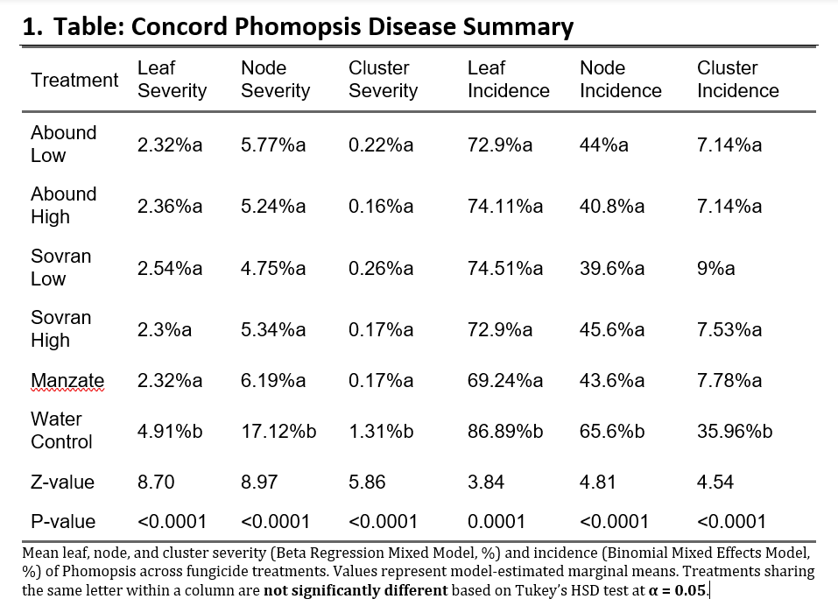

Chart 5
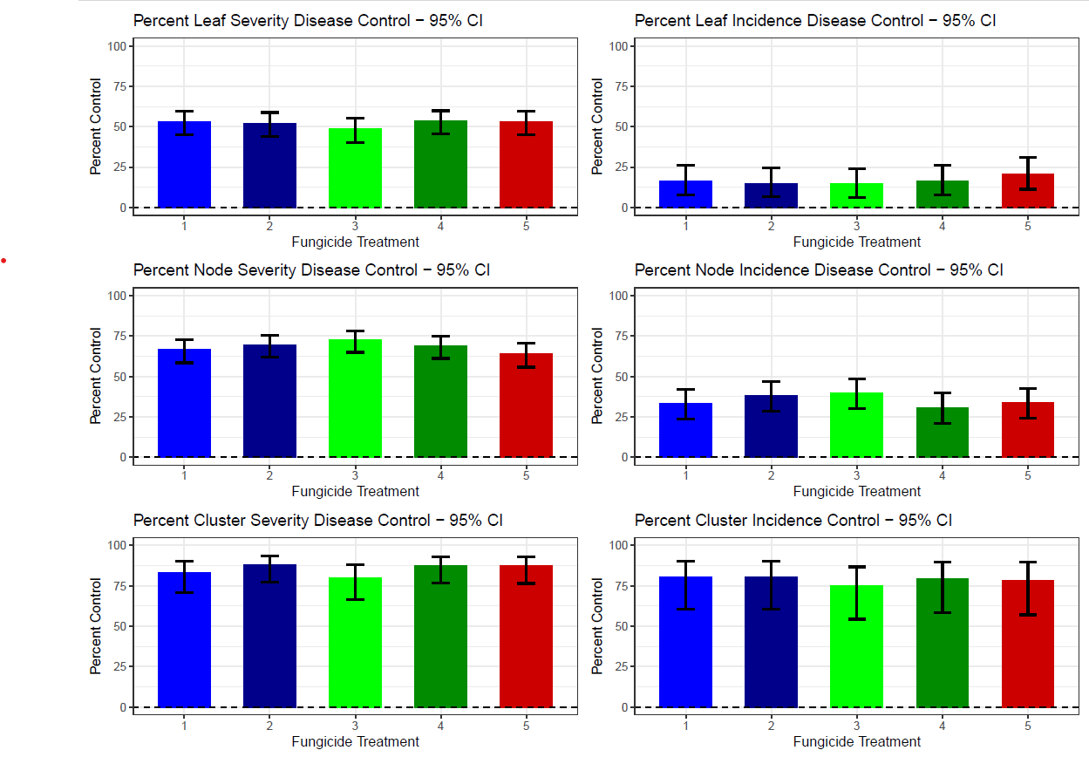
Treatment Key:
1 - Abound Low
2 – Abound High
3 – Sovran Low
4 – Sovran High
5 – Positive Control Manzate

References:
Baudoin, A., Olaya, G., Delmotte, F., Colcol, J. F., & Sierotzki, H. (2008). QoI resistance of Plasmopara viticola and Erysiphe necator in the mid-Atlantic United States. Plant Health Progress, 9(1), 25.

Bock, C. H., Gottwald, T. R., Parker, P. E., Ferrandino, F., Welham, S., Van Den Bosch, F., & Parnell, S. (2010). Some consequences of using the Horsfall-Barratt scale for hypothesis testing. Phytopathology, 100(10), 1030-1041.

Brown, B., Gold, K., Hed, B., Helms, M., Loeb, G., & Sosnoskie, L. (2024). New York and Pennsylvania pest management guidelines for grapes (pp. 21–25). Ithaca, NY: Cornell Cooperative Extension.

Wilcox, W. F., Gubler, W. D., & Uyemoto, J. K. (2015). Compendium of grape diseases, disorders, and pests (2nd ed., pp. 68–72). St. Paul, MN: American Phytopathological Society Press.

